- Red= quiet and calm. Loves a sit down with anyone and is confident on her own. Little sweetheart! Triangle shape on her tummy!
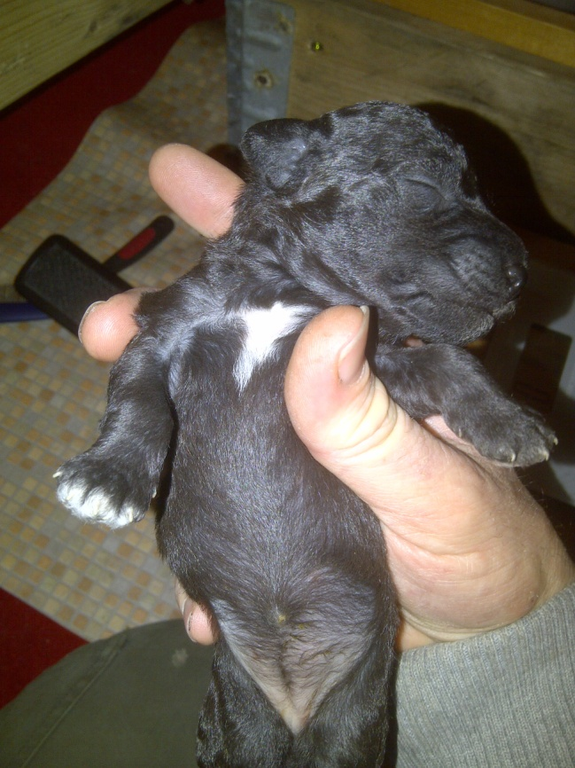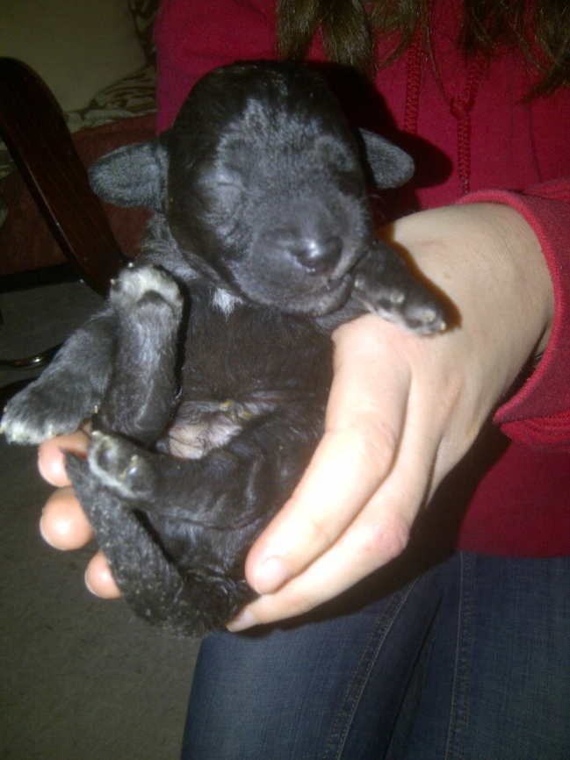

- Blue= loves to sleep and likes cuddles! Peedie white paws and a very white tummy!


- Green= tiny little guy with a wonderful personality. Very cute, calm and quiet! Batman logo shape on his tummy.
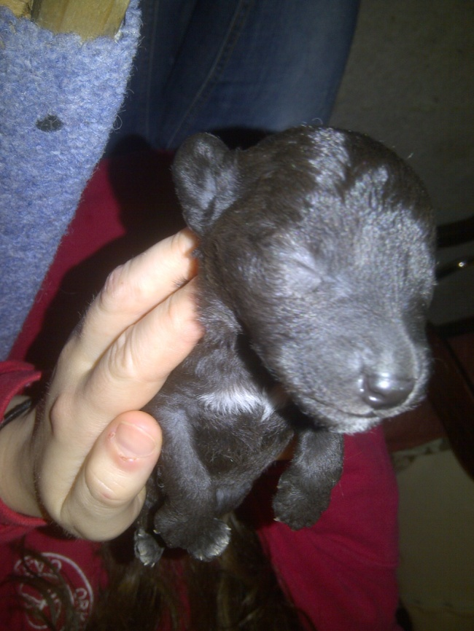

- Orange= like a little teddy bear, loves to eat and trying to be on his feet! He has a white triangle shape on his tummy!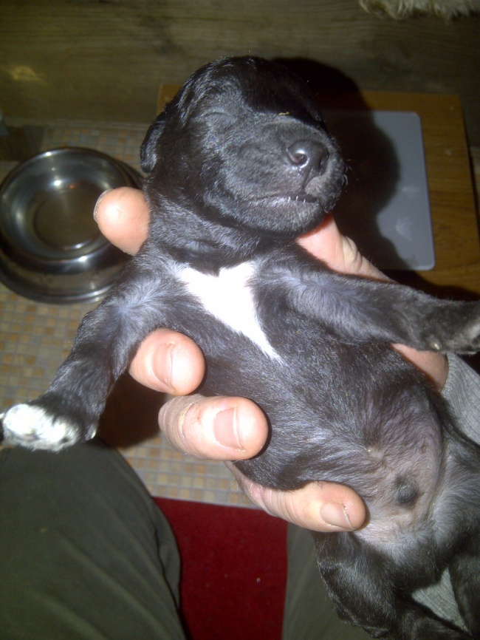

- Violet= from being the smallest she has grown so much and doesn’t let the bigger pups have all the food. Very cute! Vague white heart shape on her tummy!


- White= strong and healthy with a great appetite and a very cute little face. He has a “r” on his tummy!

- Yellow= loves to be with her mom with a very sweet personality. She has a tiny white dot beside her front left paw!
